Ques 1

Code:

#include <stdio.h>

#include <unistd.h>

int main()

{

int a;

a = fork();

if (a == 0) {

printf("Child Process\n");

} else if (a > 0) {

printf("Parent Process\n");

} else {

printf("Fork failed\n");

}

return 0;

}

Output:

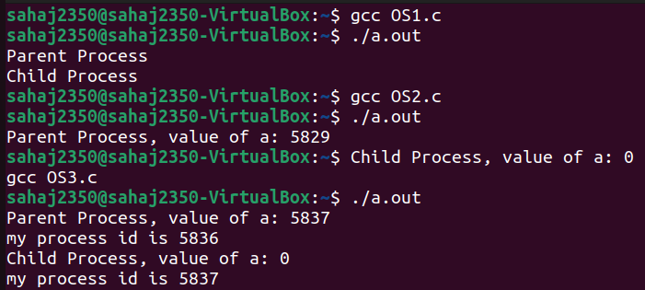

Ques 2

Code:

#include <stdio.h>

#include <unistd.h>

int main()

{

int a;

a = fork();

if (a == 0) {

printf("Child Process, value of a: %d\n", a);

} else if (a > 0) {

printf("Parent Process, value of a: %d\n", a);

} else {

printf("Fork failed\n");

}

return 0;

}

Output:



Ques 3

Code:

#include <stdio.h>

#include <unistd.h>

int main()

{

int a;

a = fork();

if (a == 0) {

// This is the child process

printf("Child Process, value of a: %d\n", a);

printf("my process id is %d\n",getpid());

} else if (a > 0) {

// This is the parent process

printf("Parent Process, value of a: %d\n", a);

printf("my process id is %d\n",getpid());

} else {

// Fork failed

printf("Fork failed\n");

}

return 0;

}

Output:

